

AMERICAN INTERNATIONAL UNIVERSITY–BANGLADESH (AIUB)
dDept. of Computer Science
Faculty of Science and Technology
CSC2210: OBJECT ORIENTED PROGRAMMING 2
Summer 2024-2025
Section: [R]
Group No: 06
Project Report On
Human Resource Management System
Supervised By:
Mehedi Sayed
Submitted By:
Name | ID
Mohammad Sohanur Rahman | 23-53829-3

CO2: Display and verify the mean of a real-life Project using the concepts of C# Graphical User Interface based environment with database integration to depict a desktop-based application.
Assessment  Criteria | Not Attended/ Incorrect (0) | Inadequate  (1-2) | Average  (3) | Good  (4) | Excellent  (5)
Evaluation Criteria | Evaluation Definition |  |  |  | Total =
Requirement fulfillment | Properly demonstrate a real-life scenario-based project with proper functional requirement identification for the Object-Oriented Programming project development activities.
Validation | Ensuring the ability of students’ proper demonstration on validation forms in their system in terms of dealing with the data.
Verification | Identifying if the students can verify the system data along with proper functional requirements in terms of data flow.

Table of Contents Page No.

1. Chapter: 01 (Introduction) ------------------------------------------------ 03
2. Chapter: 02 (User Story) --------------------------------------------------- 04
3. Chapter: 03 (ER Diagram) ------------------------------------------------- 05
4. Chapter: 04 (SQL Quaries) ------------------------------------------------ 06
5. Chapter: 05 (Screenshots) ------------------------------------------------- 07

Chapter: 01 (Introduction)

The Human Resource (HR) Management System is a database-driven application developed to automate and streamline HR operations within an organization. It manages employee information, payroll, salary details, education, work experience, department, and designation records efficiently.
The system includes three user roles: Admin, HR, and Employee. Admin and HR users have full access to manage, view, edit and delete all employee data, while Employees can only view their own information, ensuring data privacy and security.
Key features include:
- Employee Information Management
- Payroll and Salary Processing
- Department and Designation Tracking
- Education and Work Experience Records
- Salary Slip Generation
Developed using C# and SQL Server, the system ensures data accuracy, integrity, and easy access. It provides a reliable and efficient solution for managing organizational human resource activities.

Chapter: 02 (User Story)

Admin User Story
- As an Admin, I want to have full control over the HR Management System so that I can manage all employee records, departments, designations, salary and payroll information.
- I can create, update, and delete new and existing employee profiles.
- I can manage user accounts, including HR and Employee access.
- I can add new employees, assign departments and designations, and record educational and work experience details.
- I can view and generate reports related to employee performance, salary, and department statistics.
- I can ensure the system runs smoothly and securely by maintaining database integrity and overseeing all HR operations.

HR User Story
- As an HR user, I want to manage and update employee-related information so that I can maintain accurate and up-to-date records for the organization.
- I can add new employees, assign departments and designations, and record educational and work experience details.
- I can process payroll, update salary information, and generate payslips for employees.
- I can view all employee data.
- I can ensure that employee and organizational data remain organized and easily retrievable.

Employee User Story
- As an Employee, I want to log in to the system to view my personal and professional details so that I can stay informed about my information.
- I can view and edit my personal profile, only view salary details, and generate payslips.
- I cannot view or edit other employees’ information.
- I can ensure my own data remains accurate and keep my profile updated.
- I can securely access the system to check my salary history, payslips and employment records.

Chapter: 03 (ER Diagram)

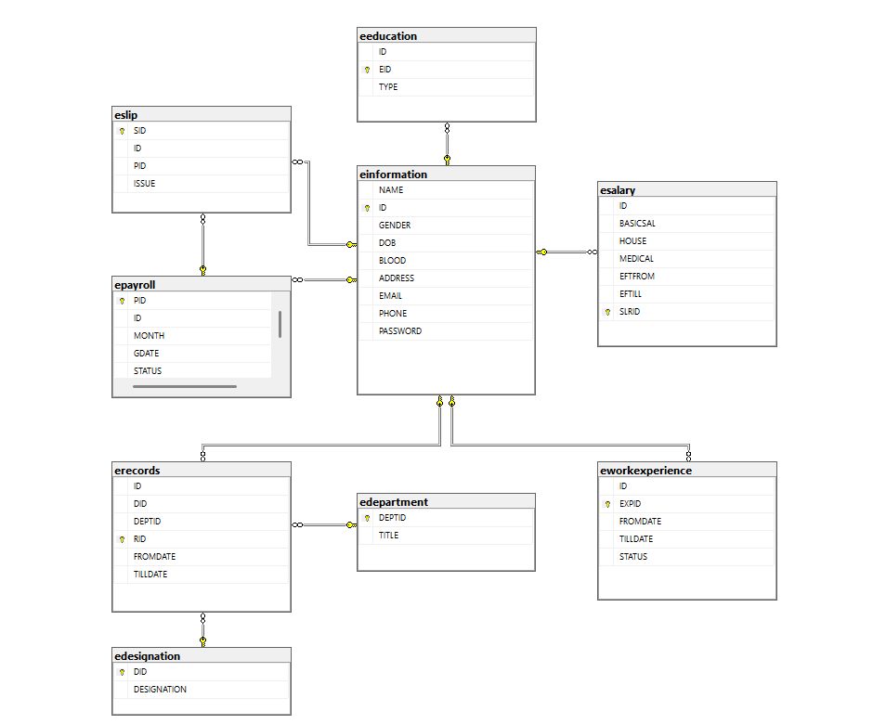

Chapter: 04 (SQL Quaries)

  - “insert into edepartment Values('" + TITLE + "')";
  - “Update edepartment set TITLE='" + TITLE + "' Where DEPTID=" + txtdeptid.Text;
  - "delete from edepartment where DEPTID=" + txtdeptid.Text;
  - "insert into edesignation Values('" +DESIGNATION+ "')";
  - "Update edesignation set DESIGNATION='" + DESIGNATION + "' Where DID=" + txtdid.Text;
  - "delete from edesignation where DID=" + txtdid.Text;
  - "select eeducation.*, einformation.NAME from eeducation inner join einformation on einformation.ID = eeducation.ID ";
  - "insert into eeducation Values( '"+ID+"','" + TYPE + "')";
  - "Update eeducation set ID='"+ID+"',TYPE='" + TYPE + "' Where EID=" + txteid.Text;
  - "delete from eeducation where EID=" + txteid.Text;
  - "insert into einformation Values('" + NAME + "','" + GENDER + "', '" + DOB + "','" + BLOOD + "','" + ADDRESS + "','" + EMAIL + "','" + PHONE + "', '" + PASSWORD + "')";
  - "Update einformation set NAME='" + NAME + "',GENDER='" + GENDER + "', DOB='" + DOB + "',BLOOD='" + BLOOD + "',ADDRESS='" + ADDRESS + "',EMAIL='" + EMAIL + "',PHONE='" + PHONE + "',PASSWORD= '" + PASSWORD + "' Where ID="+txtid.Text;
  - "delete from einformation where ID="+txtid.Text;
  - "select epayroll.*, einformation.NAME from epayroll inner join einformation on einformation.ID = epayroll.ID ";
  - "insert into epayroll Values('" + ID + "','" + MONTH + "','" + GDATE + "', '" + STATUS + "')";
  - "Update epayroll set ID='" + ID + "', MONTH='" + MONTH + "',GDATE='" + GDATE + "', STATUS='" + STATUS + "' Where PID=" + txtpid.Text;
  - "delete from epayroll where PID=" + txtpid.Text;
  - "insert into eslip Values('" + ID + "','" + PID + "','" + ISSUE + "')";
  - "Update eslip set ID='" + ID + "', PID='" + PID + "',ISSUE='" + ISSUE + "' Where SID=" + txtslip.Text;
  - "delete from eslip where SID=" + txtslip.Text;
Chapter: 05 (Screenshots)

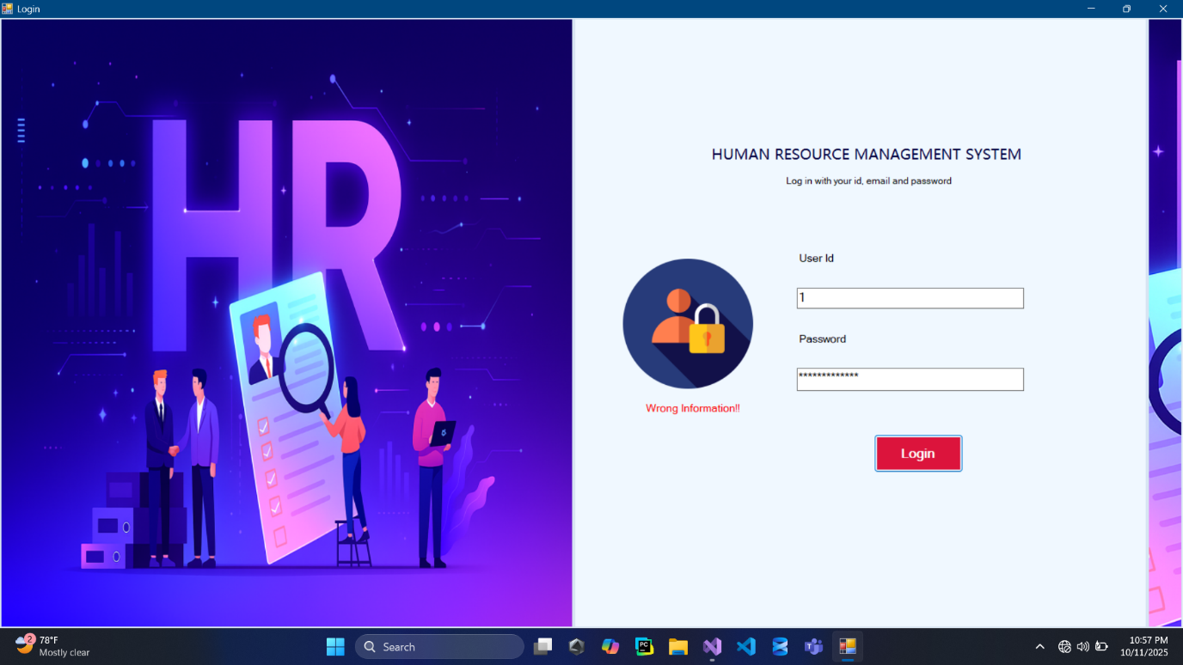
Login Page

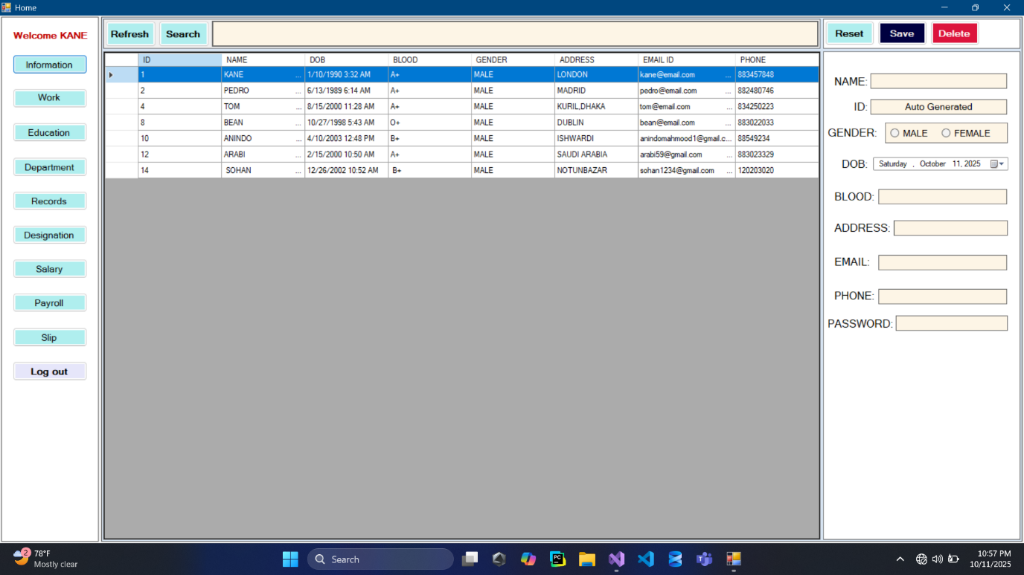
Information View

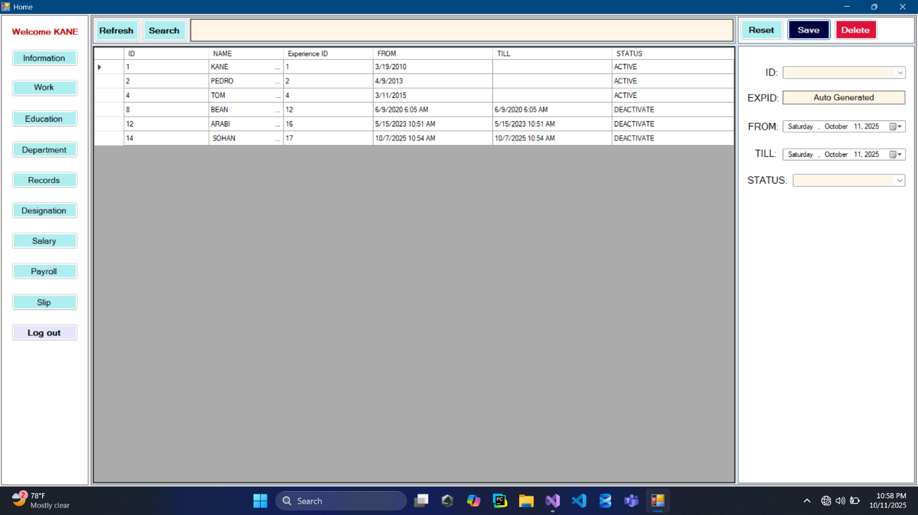
Work View

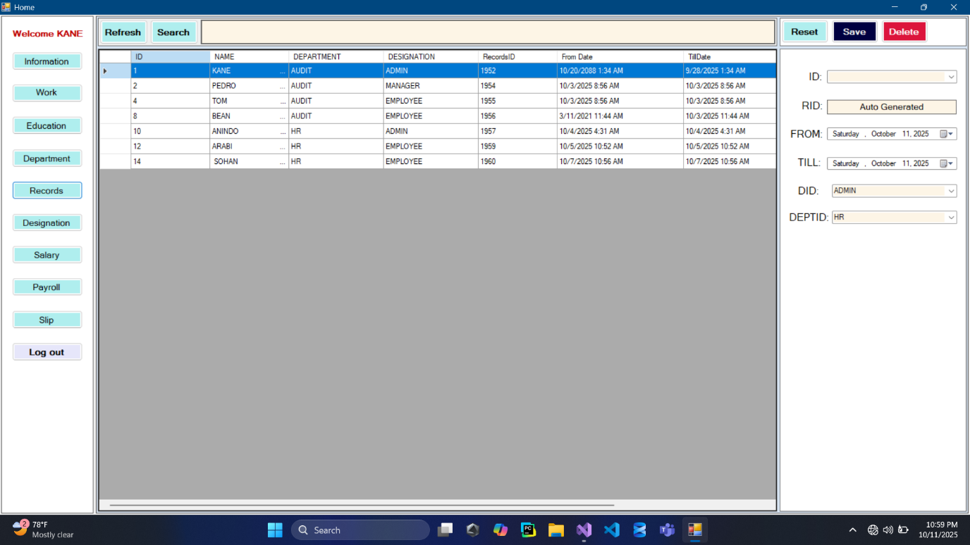
Records View

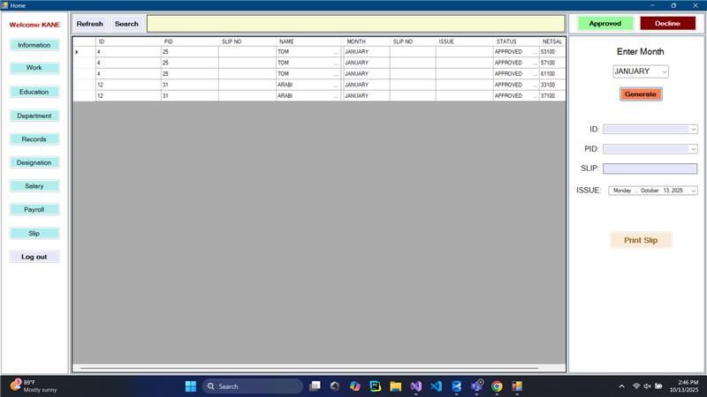

Slip View

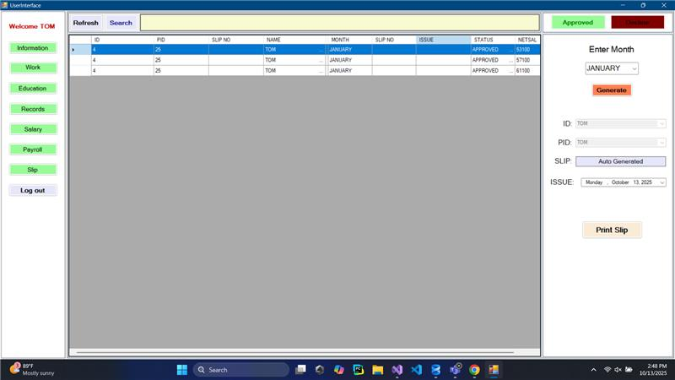
User Interface Slip View

